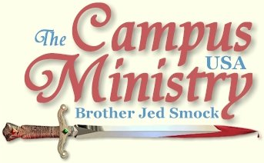
brojed.org
brojed@aol.com
573-999-0347
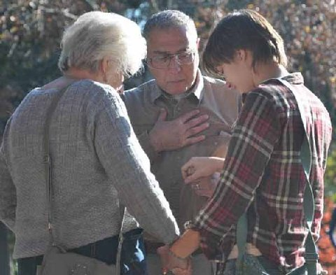
Bro. Raymond and Sis. Sheila pray with a girl at Georgia College: Read details below!

DADDY’S LITTLE GIRL
Virginia Commonwealth University, November 8, 2010,
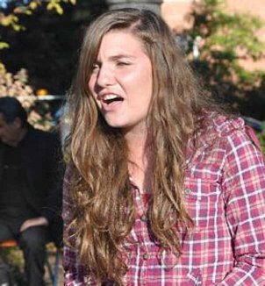
"She is not easily intimidated."
Since this is the first time I have been on this campus, I sent an email to the Student Affairs office and to the police that I would be exercising my first amendment rights on campus. I preached on the Compass in front of the dining hall. I had not been preaching 10 minutes when Dr. Reed, Director of University Student Commons and Activities, introduced himself. He gave me his card and asked me to contact him if I needed anything. He said he used to hear me as a student at Ohio State. He thanked me for informing him that I would be speaking on campus.
Other preachers warned me that this campus is “very wicked” and “uncivil” with a large community of homosexuals. My experience was that the students were relatively civil and I did not have that much of a confrontation with homosexuals, although, two lesbians did kiss in front of me for a few minutes.
At the noon break 10-12 students stopped for a while and I did get some dialogue going but that died out. As I was sitting with Martha, two Christians from the Aletheia Ministry introduced themselves and after questioning me, decided that I was alright. Meanwhile, Rev. Roger Sutter, Consuming Fire Ministries, introduced himself. He is an associate of a preacher friend, Paul Richardson, whom I have known since the 70’s. One of the brothers from Aletheia prayed for me before I started again.
This time I did draw a sizable crowd. One fellow was in my face for sometime claiming Jesus was a communist because he said blessed are the poor and woe unto the rich. He was a buzzing pest in my face for almost an hour. But most of the students were civil.
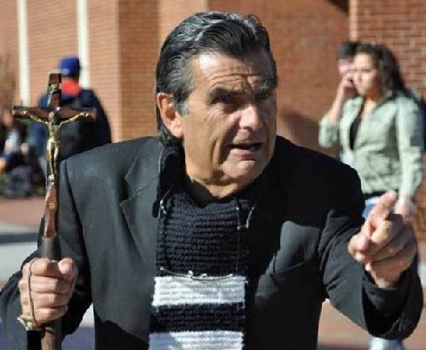
"Most of the students here were civil."

I noticed that Rev. Sutter had a small group around him. I was happy that he had an opportunity to evangelize. Rev. Sutter and my old friend Paul, a Pentecostal, believe that the Book of Mormon is inspired and compatible with the basic doctrines of Christianity, but they do not believe that Mormons are following their own book. Rev. Stutter has made eight mission trips to Viet Nam.
About 2 PM my audience which had encircled me at a distance enclosed around me. A covered Muslim female was intense in claiming that Christians, Jews and Muslims all worship the same God. Her attitude was that we all must get along. There was a big fellow who defended me and argued with the Muslim gal that the Christianity and Islam are not compatible since they are contradictory Finally, the group got so vociferous in arguing with one another that I walked away. I waited about five minutes and started speaking again. Another crowd gathered around me, which again was argumentative not just with me but one another. I left campus at 3:40 since we had a three hour drive to UNC to preach tomorrow.
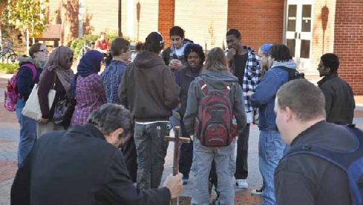
"Finally, the group got so vociferous in arguing with one another that I walked away."
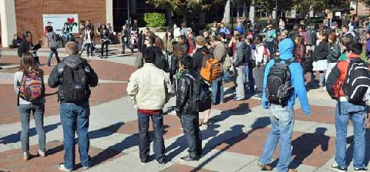
Virginia Commonwealth University
When we got back to the parking lot, we got a call from Brennan Hartley, who had been a student in my school of Theology in Newark, OH, in the early nineties. Brennan now lives in Richmond. In a facebook message the other day he had encouraged me to preach at VCU which had not been on my schedule. Brennan was on campus looking for me. We were able to meet briefly for about 10 minutes of fellowship. Brennan has become a devout Roman Catholic. We often communicate over facebook. It was good to see him after all these years and meet his wife and son.
Martha gave her story of HPV Holly. Some unbelievers conversed with Martha on the sidelines. They said to Martha, “It is great the way you stick up for your dad.”
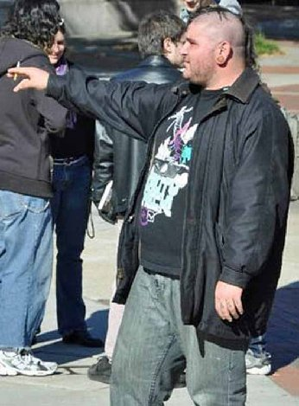
Preaching in the Pit
University of North Carolina, November 9, 2010
I preached in what is called the Pit just outside the Student Union. There was a dance group raising money for a children’s hospital with whom I had to compete for attention. They were apparently engaging in good clean fun but they tended to get loud at times and served as a distraction from the preaching. At times I stopped preaching since they were occupied in a worthy cause. There were a lot of people milling around the area and talking to one another. I did gather an audience of fifteen or so for a while. But I had difficulty engaging them in conversation. Some seemed to be listening, but after 30 minutes most everyone left. I decided to take a break. Martha and I read and pondered Hebrews 13 as we were waited for another flow of students. There were still many hanging around the area but they seemed preoccupied.
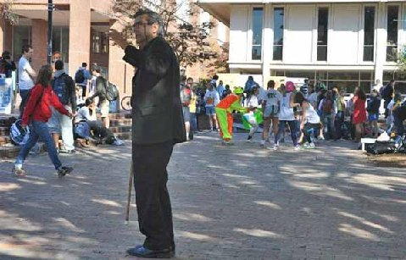
The distracting dancers are in the background on the right.
At 1:30 I gathered another audience. And this time I did get good interaction going. The students were polite and civil. I spoke out against homosexuality and sang the gay song during both my first and second stint. Amazingly, no one defended homosexuality, which is rare these days. However, I do not expect that to last over the next two days at UNC. The roles of men and women were discussed but the students were not particularly argumentative against my position. Mostly, their questions were an attempt to understand my positions on issues. I spent a good hour comparing other religions and philosophies to the Christian answers to the questions of origins, meaning, morals and destiny.
No one even told me today that I was going about it in the wrong manner. Actually, as I was leaving campus one fellow shook hands with me and commended me for my rational approach to religion. Except for the frustrations during the first 90 minutes to gain the students’ attention it was a delightful day. The crowd that gathered on the steps of the Pit probably never exceeded 25 people although there may have been others listening at a distance. There never seemed to be an appropriate time to call on Martha. No one defended fornication so Martha’s stories of HPV Holly or Herpes Henry did not seem to fit into the flow of the conversation. Since the dialogue was going so well, I did not want to interrupt it with Martha’s skit. No one came over and talked to Martha today. I did introduce her at one point and she gave the crowd one of her big smiles.
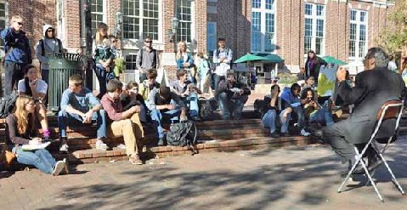
"..it was a delightful day!"
THE YOUNG GENERATION OF PREACHERS
University of North Carolina, November 10, 2010
Ross Jackson, from eastern North Carolina, joined me on campus today. He is a disciple of Micah, who was influenced to go into campus evangelism by reading my book, Who Will Rise Up? Today we preached on the Library Mall since the Pit was occupied by three campus groups. Ross opened the preaching, not waiting for the class break, and quickly drew a crowd. Ross interacts with the students in a very humorous way and has style in his preaching. He has good one-liners like, “I am not as dumb as you look.” He said to a coed who was wearing short short cut off jeans with horizontal stripped stockings which reached within an inch of her shorts, “Did you have chicken for lunch?” “No,” the brazen woman answered. “Yes you did, you must have. Your mouth is so foul.”
“There are five ways to identify a lesbian,” Ross said. 5. She wears men’s underwear, 4. Short hair, 3. She watches Ellen DeGeneres, 2. She is on the women’s basketball team, 1. She has sex with women.” With 5 through four you can be 99% sure, with number 1 you can be absolutely sure, according to Ross.
Ross has an amazing grasp of the Scriptures for someone who has been a Christian for only four years. He quotes large portions of the Bible. He speaks against Obama. Ross is a black brother, who is straightforward in his preaching but is not at all mean spirited in his stern rebukes.
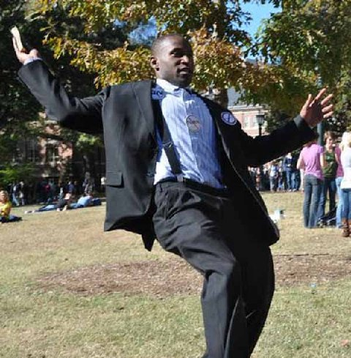
Ross Jackson, a young preacher from North Carolina
Ross and I alternated throughout the afternoon. About 4:45 I called upon Jennifer O’Conner, who came to campus with her father Pat. Pat is a marine buddy of Mitch Metzger. Pat and Jennifer came to my last SOE conference in Columbia several years ago. At the time I labeled her “Jen of Arc,” since she even then was so bold and militant in her evangelism. She had an illustrated sermon prepared using an empty bottle to show the emptiness of a sinner’s life. A full Pepsi bottle illustrated the life full of sin. She filled the empty bottle with clear water to demonstrate the life filled with the spirit of God. It was an effective attention getter. Jennifer is 19 and has the fire of Sister Cindy. Martha assisted the young warrior in her illustrated sermon.

"Jen of Arc" gives a Gospel illustration with the help of Martha


Pat finished the day talking to students. The last hour we each had students with whom we were talking. At 6 PM, we all went to Lenior Hall on campus for a buffet dinner and good fellowship.
It is interesting meeting the new generation of campus preachers that God is raising up. Ross is in his late 20’s and single. I strongly advised him not to marry until he had built up a strong financial base for his ministry. I have seen too many, who, like Ross, get off to a strong start in open-air evangelism, get married and children soon follow. But they are unable to keep the ministry going and support the family and before long they are rarely preaching in the open-air. Ross indicated that he had a part time job on a night shift which helps pay his expenses to preach on campuses in the Southeastern part of the country. His flagship campus is Eastern Carolina University where he also graduated.
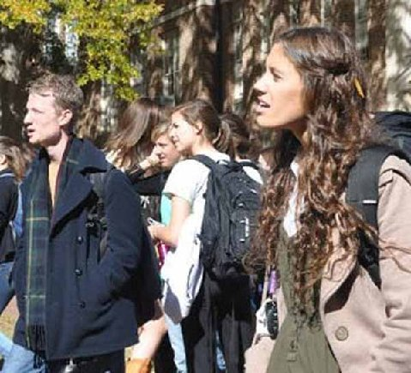
Listeners at the University of North Carolina
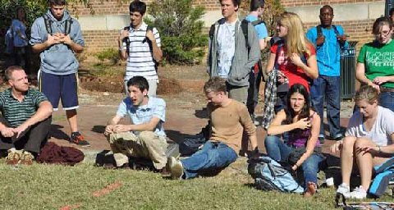

THE GREAT ADVENTURE
University of North Carolina, November 11, 2010
This week I receive the following email messages from Buddy Fisher, “I would love any advice you are able to give to me. I have been a Christian for 23 years but spent about 20 of those years as an average Christian who shared his faith when opportunities arose, but didn’t go out of his way to preach to people. Over the last 3 years I have finally come alive and have been a street preacher at every available opportunity. I am originally from the Cleveland, Ohio area, but I have lived in NC since 1993.
I will continue to preach at as many places as I can on the nights and weekends, and try to hit the colleges in my area on some days off. And to answer your question from your 1985 book, “I will rise up, Brother Jed!” My backpack says “Here am I Lord. Send me.” Thank you for inspiring me, and God bless you on your next campus!
Evidently, it was no coincidence that Mr. Fisher emailed me the week I was in his home state preaching. He did not know my schedule. He took today off work to join me on campus. And he will join me tomorrow at UNC Charlotte.
Ross Jackson rejoined us today at UNC. I opened the preaching on the Library Mall and drew a crowd which reached up to a hundred for much of the afternoon.
Buddy Fisher took his turn at 3 PM. He opened by warning his audience that he was not funny like Ross and me. He was converted while attending college at Miami University in Oxford, OH. His preaching was straightforward, rapid fire and doctrinally sound. His experience has been mostly event preaching so he needs practice in learning the art of interacting with the students. He enjoyed the opportunity to field questions from his audience which he noted is not typical of the event outreaches. He was effective which was evidenced by the fact that, although he lost some of the crowd, after he turned the meeting back over to me, a half dozen students surrounded him with questions. He stayed with this group for almost two hours.
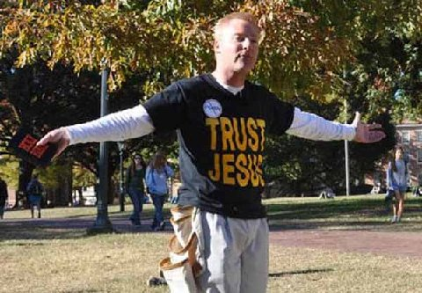
"Over the last 3 years I have finally come alive and have been a street preacher at every available opportunity," Buddy Fisher
I ended up losing much of the remaining crowd after almost an hour of preaching. By 4:15 it looked like things had died out and I thought we would call it a day early than usual. However, I have noticed there is a lot of traffic on this campus late. Therefore, when I saw some movement, I raised my voice again saying, “I am holding a library in my hand. I am holding 66 books, by forty authors written over a period of fifteen hundred years.”
I hammered on the importance of the Bible and its impact on Western Civilization and strongly rebuked students for their Biblical illiteracy. I pounded the University for not acknowledging the importance of the Bible. My message drew a new crowd of 25 or so and I taught until almost 6 PM. I had good interaction with a Jew who had a working knowledge of the Torah. I kept pressing him to explain the rational of the dietary laws, circumcision, and other rites and rituals of Judaism. I explained the symbolism of the stories of the Passover and Abraham’s sacrifice of Isaac. I taught on some the Messianic prophesies. The young man was attentive and had an open mind.
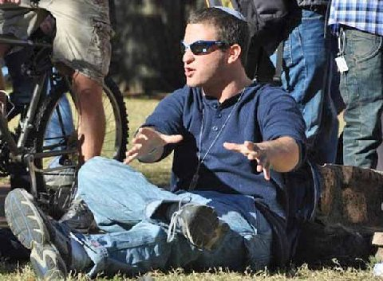
Jewish Student
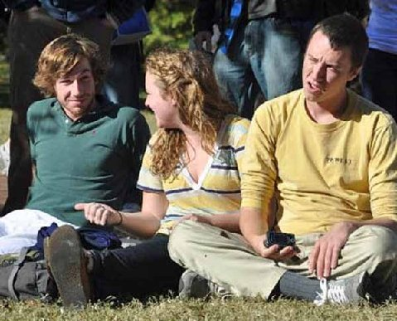
They are talking about the Gospel!
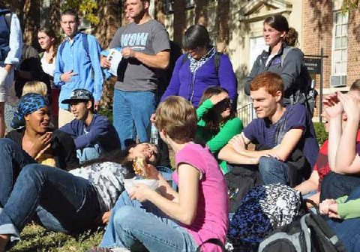

Girl with holes in her arguments
Mr. Fisher took Ross, Martha and me to dinner. Mr. Fisher indicated that he became interested in open air preaching as a result of videos he watched on YouTube. He said, “Since I started the open-air preaching has been the most exciting time of my life. It has been a great adventure.”
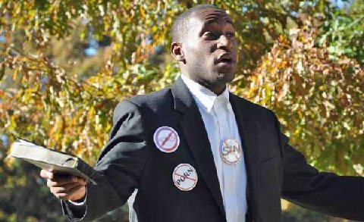
MIZZOU CALLING
November 12, 2010
There are so many campuses which are starving for hearing the truth. I often wish that I could be many places at once. I received the following facebook message from a student at the University of Missouri, “Mizzou misses you. There are other preachers here but it’s just not the same. Come home soon.”
Today, I preached at UNC Charlotte. Buddy Fisher met us there holding his large banner. He managed to get Kenny to stop with whom he had an hour long conversation. There was very little flow at the class break. I did not get anyone to stop. I inquired from a few students and they told me there are few Friday classes. The campus seemed dead. After about 30 minutes of preaching, I decided to drive on to the Atlanta area, which is about a four hour drive, where Martha and I will be hosted by Raymond and Sheila D., who have been friends of the ministry going back to the 70’s. Without people like them, it would be very difficult to carrying on this calling from the Lord.
In retrospect, I probably should have stayed another day at UNC Chapel Hill, which is a good Friday campus. Many campuses today seem to going to a four hour work week. Personally, I like a five day work week. But then I like what I do.
BATTLING HYPOCRITES
Georgia College and State University, November 15, 2010
The designated free speech area is a considerable distance from the sidewalks. I decided to hold the banner to help gain the students’ attention. It is the first time I have used a banner this fall. I preached for over an hour and except for having a few friendly students come up and talk to me for a few minutes, I could not gain an audience. After an hour I was frustrated, thinking today would end up being a dud. I prayed that the Holy Spirit would intercede to gain the attention of students. Minutes later a group of a dozen students walked up to me all at once. Soon I opened dialogue with them. Eventually a crowd gathered of up to thirty people.
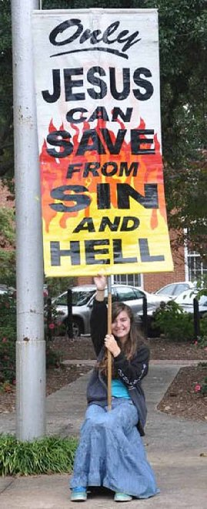
A girl who was wearing an extremely short skirt confronted me with something I had said earlier. She advanced as soon as the group approached. She quoted me as saying earlier, “You girls that are exposing so much flesh might as well have a sign on your back saying, ‘Rape me.’” I responded by quoting the Bible which says, “Women professing godliness ought to be modest in their apparel.” This girl had been sitting on a bench within hearing distance of me for quite some time talking with another female. I did not realize that she had been paying any attention to me. She must have felt a sense of guilt because when I made the comments I made a point not to look in her direction, although it was her immodesty which had promoted me to say what I did.
Miss Mini skirt told me she was not a Christian. I said, “Then the Biblical admonition does not really apply to you since you are not professing to be godly.”
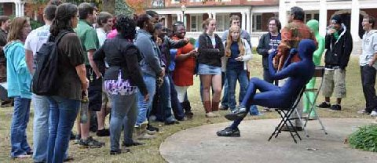
Guys appearing in body suits has become very popular on campus.
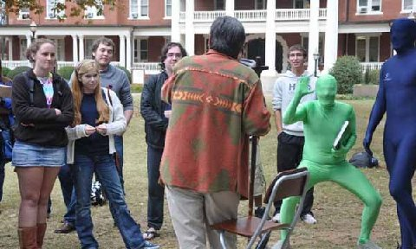
Two fellows came out carrying large Bibles obviously with the intent of correcting me without having listened to what I was teaching. They soon were justifying sin. I defended holiness. Another Christian student finally interceded and told these fellows that they were not really listening to what I was teaching. That settled down the two Bible thumpers for a time. However, eventually they started pleading for sin again. In due course, the main issue became the doctrine of original sin. I explained that one cannot inherit sin, that sin is a selfish choice.
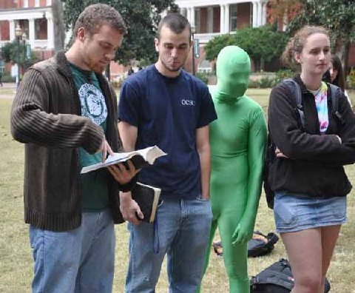
"Pleading for sin"
One of the Bible thumpers said, “God killed Jesus and God poured out all his wrath on Jesus.” I strongly objected, “Jesus was killed by wicked men; God has set aside his wrath again penitent sinners but he is more angry then ever at impenitent sinners because they have not only violated his just commandments but they have also rejected God’s beloved Son who atoned for the sins of men.”
Next Thumper claimed God gave us his law to demonstrate that we could not keep his law. I countered that if God gave us law which we did not have the ability to keep, then he would be unjust.
After 4 PM the crowd broke up into pockets that were discussing various religious issues. I decided that it was time to head back to our hosts’ home.
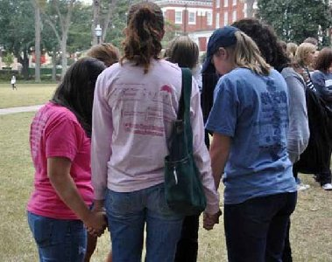
Prayer Circle

POLICEMAN PREACHES
Georgia State University, November 16, 2010
When we left the parking lot, it started raining. The best speech area on campus was occupied by a large crowd of illegal immigrants promoting the so called Dream Act, which would allow them not to have to pay out of state tuition. We went to the area in front of the Student Union to preach, where there was not significant traffic.
Frank and Jeremy, two Georgia preachers, who are a part of the SOUPA Conference met me on campus. Raymond DeFabritas, my host, opened the preaching. He did well, but did not get anyone to stop. Neither Jeremy nor I succeeded in gathering a crowd.
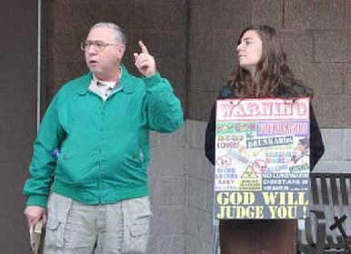
Bro. Raymond starts the meeting
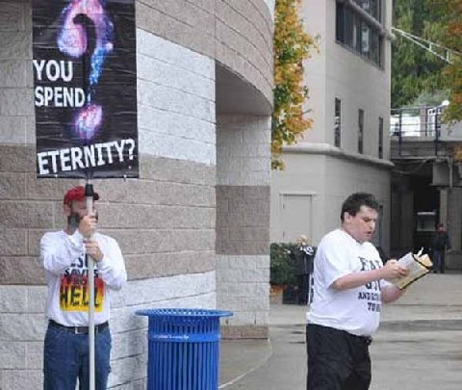
Brothers Frank and Jeremy
By 1:30 the illegals ended their demonstration. So we went to the stage area outside the library to preach. I started without waiting for the next class break. By this time we were getting a little sunshine. Raymond also took another turn. Then I preached again. A tall black fellow got into my face who was really not saying much excepting cussing. His main complaint was that I was warning him and others that they would go to the same Hell as Hitler, even though I had said nothing about Hitler. He was so beside himself and not wanting to reason that I moved off the stage and preached to some students who were listening from a wall that they were sitting upon. One of these was hippy looking girl. I could relate to her. I got on her case; she seemed to enjoy the attention. I did not want to antagonize the students at this point. I was lighthearted in relating some of my stories of my days in sin. Meanwhile, both Frank and Jeremy were dealing with the tall black guy. I finally told them to ignore him because their confrontations with him were a distraction from my preaching.
The administrator with whom I had communicated last week came out; he was complaining to Martha that I started preaching before 2 PM. The Dreamers had reserved the stage until then. But their demonstration ran out of gas and they had left the area by the time the administrator arrived. He never did say anything to me. Martha does well in dealing with the authorities. She is not easily intimidated.
The crowd became more serious by 2:30 and had questions. So I shifted into the apologetic mode. Eventually, the tall black guy settled down and stopped cursing. His main case against the Bible was what he described as, “the entirely different accounts of the Resurrection.” We even read the four Resurrection accounts from the gospels. I pointed out that the similarities are far more significant than the discrepancies in these accounts. The devil is in the details. What is significant is that all accounts agree that Jesus’ body was no longer in the tomb. All four gospels testify to the Resurrection. With such a miraculous event as Jesus rising from the dead there would bound to be some inconsistencies in the news of those who visited the tomb and in their reports of the smaller events connected with the greatest event in history. If all their accounts were all exactly the same, it would make the story seem contrived.
Jeremy and Frank both left by 3 PM. Raymond said that he counted a crowd of sixty people at the height of the meeting. I called upon Martha at 4 PM and she fielded questions for over thirty minutes. A policeman came out who told the crowd that they could not be so hostile or threaten violence. He had to defend free speech for almost fifteen minutes to those who wanted me off campus. Actually, he was doing more than defending freedom of expression. He was defending the claims of Christianity.
Raymond wanted to get on the road. Therefore, at 4:45 I announced satirically, “You people have treated me so rudely that I am leaving. But I am going to return on Friday and I won’t be so nice on Friday.”
The policeman said to me. “Don’t leave now or they will think they won.” So I stayed on for 20 more minutes.
The last two days had we allowed the weather conditions to influence us, we would have stayed home since both days spoke of a 100% chance of precipitation. We do not run out of gas.
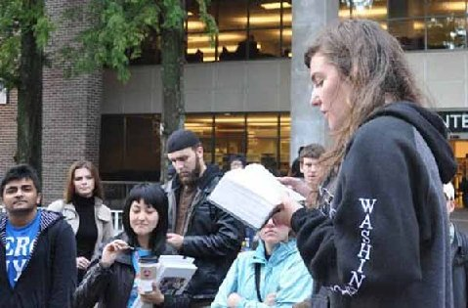
Martha fielded questions for about 30 minutes.
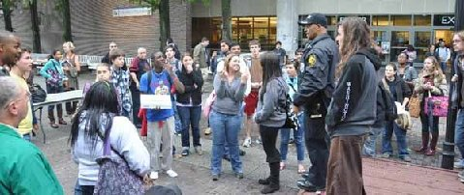
The policeman who preached is to the right, front of Martha

A NEW CAMPUS
Kennesaw State University, November 17, 2010
This was my first visit to Kennesaw State. Although they have a designated free speech area with a first amendment plaque, they require three days notice for a permit to use the area only from 12-3. So they do have a ways to go in support of freedom of expression. Zach Baxter, an Atlanta Street preacher, made the necessary arrangements.
There never seemed to be a lot of traffic. We did gather a small and attentive crowd. After about 30 minutes of preaching on the moral issues, I went into the teaching mode. A young man, who grew up in a Christian home, was now professing to be a Buddhist. I challenged him to give coherent answers to the four fundamental questions of origins, meaning, morals and destiny. I lectured a good hour on these subjects. At the end of the hour he acknowledged what I taught made sense. I taught that men universally acknowledge moral obligations. The existence of these obligations make more sense in a universe where ultimate reality is a moral Person then one in which moral persons are a late and insignificant byproduct of impersonal forces. Buddhism does not have an ultimate reality who is a moral Person. Buddhism teaches that all is one. If true, then ultimately good and evil are one. Or should I say, is one? Yet he like everyone else he makes moral distinctions. Neither the Buddhist, materialist, or naturalist can reasonably or coherently account for moral obligation, as least to the extent that Christianity is able to do so. Truth ought to work, that is provide smooth answers to the questions of life.
The students were very attentive during this lecture. Afterwards Zach said, “You are more of a teacher than a preacher.” I suppose after initially getting the students’ attention through preaching, Zach is right, I am mostly a teacher.
A student accused Christians of not being Christ-like. I asked him to explain what Christ was like. He answered, “He did not wear a sport coat and tie.” I responded, “I think we are all aware of that.”
I agreed that most professing Christians are not Christ-like but true Christians are. I used the C.S. Lewis argument that if Christ was not whom he claimed to be, the Son of God, then he was a lunatic or liar. The fellow answered, “How do we know he was not a liar?” I responded, “Your accusation that Christians are not Christ-like implies that it is good to be Christ-like. Is it good to be a liar? I do not think you or anyone else would make that claim. So he must have been whom he claimed to be the Son of God. For I doubt if you believe it is good to be either crazy or deceived.”
Later he cried, “If there be a God, strike me dead.” I quickly look up to Heaven and pleaded, “God do not do it, have mercy on this man.” After a pause, I said, “See God answered my prayer not yours, demonstrating God’s longsuffering and kindness.” I must give credit for that tactic to Bible Jim Webber.
At 2:15 I handed the meeting over to one of the other preachers. We left campus at 2:30 since most people had left and we did not have time enough on the permit to build another crowd. It was a low key day but I thought a profitable one. Martha gave her skit and the students applauded her. Zach requested that I sing, “The House of the Rising Sun.” The crowd also applauded me at the end of the song. Two or three policemen observed thorough out the afternoon.
STUDENT FINDS FORGIVENESS
Georgia College and State University, November 18, 2010
Cindy and Priscilla and Raymond and Sheila Defabritas joined Martha and me. This was a different day from Monday, when I preached on this campus. For the first two hours students stood or sat at quite a distance from the free speech area. They were listening but not responding. My primary antagonists on Monday came from the Christian community which wanted to defend sin as well as some Calvinists defending their dreadful decrees. But I did not have a significant problem with them today.
A about 2 PM a maintenance man set up four barriers between me and the students. I supposed that the authorities had ordered this. I thought it was unnecessary, especially since the students were already at such a distance and had been so calm. However, I was glad they did so because it draws more attention to our speaking and it draws the line between the defenders of darkness and the defenders of the light. The barriers had the effect of drawing the students to sit closer.
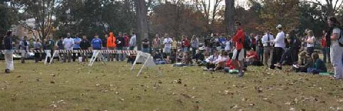
Sister Cindy (left) preaches behind the barriers.
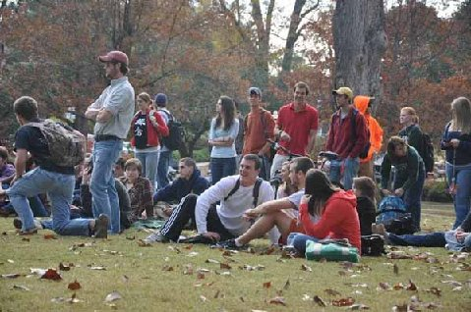
Beautiful day for preaching the Gospel!
Raymond related his testimony of growing up as a devout Catholic in the South Bronx, who slipped into the depths of sin from 19 years old to 29. By 29 he was working in as a lab assistant for Lucent Corp. under Dr. Sam Brockway, who for a period of six months read the Bible to Raymond on their lunch break. After six months Raymond confessed his need for salvation and repented in Dr. Brockway’s office. He never looked back but spent 10 years in Bible College learning the ways of the Lord, while continuing to work for Lucent. Raymond is now retired. The students were attentive as Raymond gave his testimony.
Cindy spoke on the sins which will result in the sinner being cast into the Lake of Fire. Students soon picked up on her repetition of the phrase Lake of Firrrreee. Soon they were repeating with her, Lake of Firrreee. It was a sight and sound to behold and hear.
Meanwhile, Mary walked across the barriers to speak to Raymond and Shelia. She tearfully confessed that she was a Presbyterian who could not overcome temptation. It was clear to Raymond and Sheila that Mary had a broken and contrite heart and they were able to pray with her for the salvation of her soul.
Soon others approached Raymond and he had a group of six to eight around him for the rest of the afternoon. Late in the day a black man who earlier had said that he follow Christ some of the time, approached Raymond confessing that he had lost the sense of the presence of God in his life. Raymond prayed with him.
I perceive that Raymond and his wife are anointed for the campus ministry. I am praying that they will join us in the gospel road from time to time. Raymond has heard me preach many times on campuses over the last 35 years. He said, “This is the best meeting that I have seen you have.” Sheila said that she counted up to 150 students listening at a time for much of the afternoon. Sheila gave private counsel to Mary after she and Raymond prayed for her salvation.
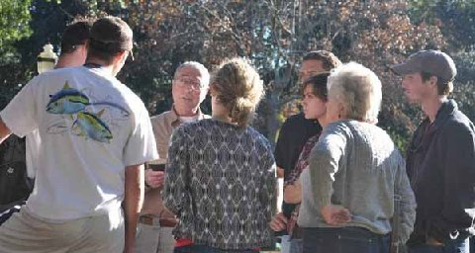
"Soon others approached Raymond and he had a group of six to eight around him for the rest of the afternoon..."
Until the middle of the afternoon the students were quiet, but the rest of the day they were rambunctious, yet not particularly hostile. A few students who were acting homo went downtown and had t-shirts made with a quote from Cindy, “EVOLUTION WILL MAKE YOU GAY.” Actually, Cindy did not exactly say this; her statement was that believing in evolution will make one more prone to become homosexual. I defended the thought. God made humans male and female. He made a woman for Adam not another man. Romans 1 speaks of men worshipping the creation whether than the Creator. Evolution teaches that man is simply a result of natural forces instead of created in the image of God. When men reject the creation model, it will make them open to all sorts of perversions. This is exactly what Romans 1 teaches. Women leave their natural use as wives and mothers to do unnatural things and likewise the men leave the natural use of the women and lust one after another, men with men, all as a result of rejecting the Creator.
The last hour I worked on trying to get the crowd into a more serious state of mind and did calm them somewhat, but there was a group who were saying vile things that some in the crowd found funny. At 5:30 I dismissed the students. Several came up and complimented me for my speaking. One of the more gross students even commended my speech. I passed out all the copies of the newsletters which I had with me. Cindy, Priscilla and Martha went on to Albany to be with Cindy’s parents to prepare for the holiday. So I will be without my Martha for the next few days.
Raymond reported that several students became teary eyed when he told them why I preach to the students. He said, “Brother Jed led so many students astray when he was an instructor and counselor in the public schools and college that he is obliged to dedicate the rest of his life to making amends by teaching the Truth to students.”
ANOTHER PROFESSION OF FAITH
Georgia State University, November 19, 2010
It was Friday with Thanksgiving Break all next week. There were few students on campus. I preached with a couple listening but not interacting for 30 minutes. I called upon Raymond. He also preached but by now hardly any students were about. Zach Baxter took a turn, but he did not get anyone to stop either. I took another crack at it at 12:50, but there was even less traffic than at the noon break. However, a student did come up to Zach and asked him a question. Zach explained to him the simple gospel message with a cube which he carries. Zach prayed with the student to receive Christ as savior. Zach is the coordinator for the SOAPA conference. He is active witnessing on the streets of Atlanta. At 1:15 we decided that we had given it a good shot and decided to call it a day.
MORMON WITH BIBLE
Florida State University, November 22, 2010
More and more campuses are taking the whole week off for Thanksgiving. A few still have classes through Wednesday. FSU changed this year and only has classes through Tuesday, which seems to be the trend. I expect within a few more years virtually all the campuses will be taking the whole week off. I do not like that. But then I like my work.
I did not have high expectations today since I suspected a significant number would cut classes Monday and Tuesday. I wore my colorful sign which pictures certain sins which lead to Hell. I started shortly after 11 which was the tail end of a class break. Since no one stopped to listen, I sat down to read Genesis 4, when a student interrupted me looking at my sign. He noted that he did not do any of the things listed. He said he was a Christian. I warned him about the one sin listed which professing Christians need to be concerned about, lukewarmness. He said that he prayed and read the Bible and did good deeds. Then he took the Bible out of his backpack. He said he was a Mormon. I rarely have encountered a Mormon who carries the Bible. In my experience they are more inclined to promote the book of Mormon. As I conversed with him others gathered. Soon they had various questions concerning my statement that Jesus is the only way to the Father.
Within an hour I had a crowd of over 50 without having to go into preaching mode. I was able to maintain that number for most of the afternoon. There were a lot of perverts in the crowd. One claimed to be a transsexual. He is evidently a male who dresses like and has taken on the mannerism of a female. I remember him from previous visits to this campus. The students all referred to this he as she. Despite all the perverts, I did have a number of students with serious questions which enabled me to reflect on the nature and character of God. There were the usual professing Christians who objected to my judging and condemning manner.
I was all and all pleased with the day. I did not have to work hard to gain a crowd. There were several people in the crowd who for much of the afternoon listened with their eyes fixed upon me. I talked to a few of them after the numbers subsided after 4 PM. Each indicated that he or she respected what I do but still did not believe. I left campus at 4:30, promising to come again tomorrow. Several expressed interest in returning to hear more.
Florida State University, November 23, 2010
I started shortly after 10 AM, knowing students would be leaving campus right after their last class. I quickly gathered a crowd of 20-25 which lasted until 1 PM when I decided to call it a day and drive to Americus, GA to be with Cindy’s family over the holiday.
I had a very good day while it lasted. The questions were good and the students were attentive to my answers. I mostly dealt with the questions of origins, meaning, morals and destiny. A professing secular humanist admitted he had no answers for meaning and destiny. For origins he simply appealed to evolution, which does not really address the issue of beginnings. My point was that a philosophy of life ought to be able to smoothly interpret life. Christianity gives us coherent, reasonable and consistent answers to the basic questions of life that others cannot answer. We often hear and use the expression, “That does not line up.” We expect things to line up. We have a machine we expect it to work. One can know he has truth because truth works.
Jesus said, “My doctrine is not mine, but his that sent me. If any man will do his will, he shall know of the doctrine, whether it be of God, or whether I speak of myself (John 7:16-17).
If men will try the doctrine of Christ, they will see that it works and that it comes from God.
You may donate to CMUSA through PayPal by going to our web site: brojed.org or you may snail mail a check to our home office: 2402 Longview Dr. Columbia, MO. Thank You!

